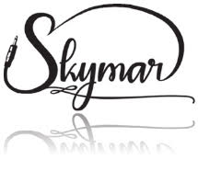

# Skymar Communications, LLC

## Direct Deposit Agreement Form

### Authorization Agreement

I hereby authorize Skymar Communications, LLC to initiate automatic deposits to my account at the financial institution named below. I also authorize Skymar Communications, LLC to make withdrawals from this account in the event that a credit entry is made in error.

Further, I agree not to hold Skymar Communications, LLC responsible for any delay or loss of funds due to incorrect or incomplete information supplied by me or by my financial institution or due to an error on the part of my financial institution in depositing funds to my account.

This agreement will remain in effect until Skymar Communications, LLC receives a written notice of cancellation from me or my financial institution, or until I email a new direct deposit form to Skymarcommunications@gmail.com.

### Account Information

|  |  |  |
| --- | --- | --- |
| Name of Financial Institution: |  |  |
| Routing Number: |  |  |
| Account Number: |  | Checking |  Savings |

### Signature

|  |  |  |  |
| --- | --- | --- | --- |
| Authorized Signature (Primary): |  | Date: |  |
| Authorized Signature (Joint): |  | Date: |  |

#### Please attach a deposit slip and email this form back to payroll@skymarcommunications.com.