WELCOME NEW AGENTS TO
SKYMAR AND IM-PRES-SIVE COMMUNICATIONS, LLC

 PARTNERED WITH ARISE
BELOW, IS EVERYTHING YOU WILL NEED. INCLUDING A LINK TO THE FAQ’S ON THE SKYMARCOMMUICATIONS.COM PAGE.

SKYMAR COMMUNICATIONS DOCUMENTS
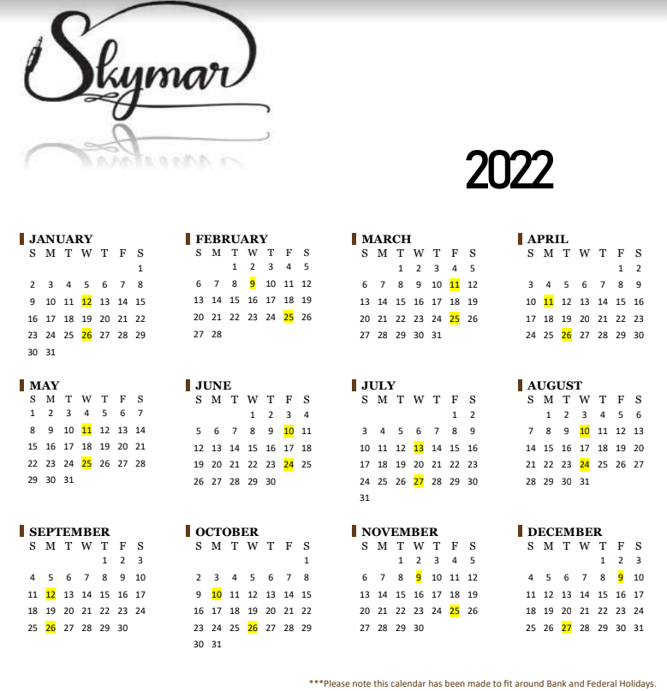
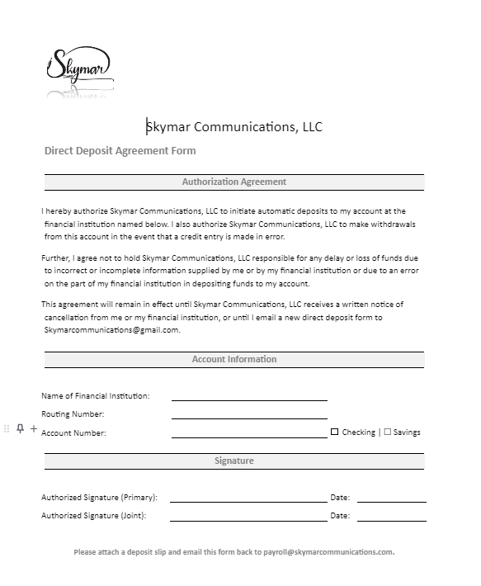

IM-PRES-SIVE COMMUNICATIONS DOCUMENTS

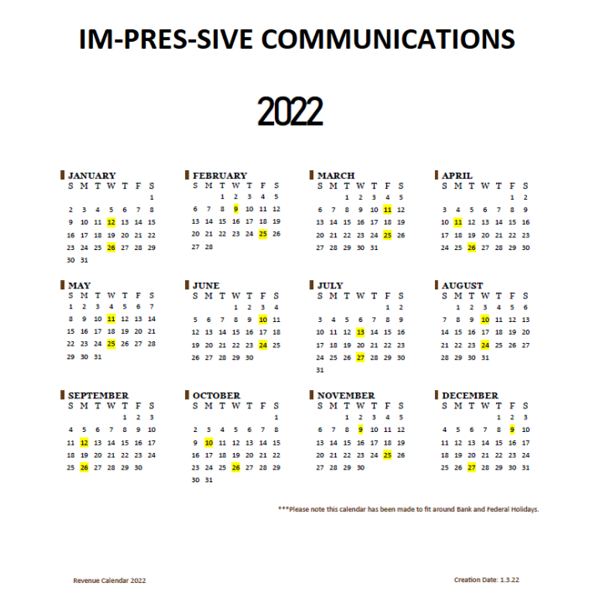


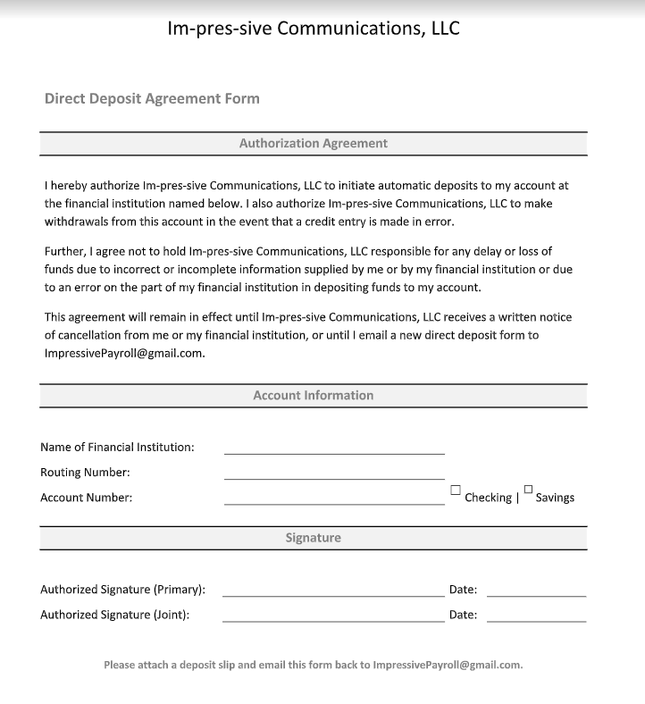

ADDITIONAL DOCUMENTS AND WHO TO EMAIL

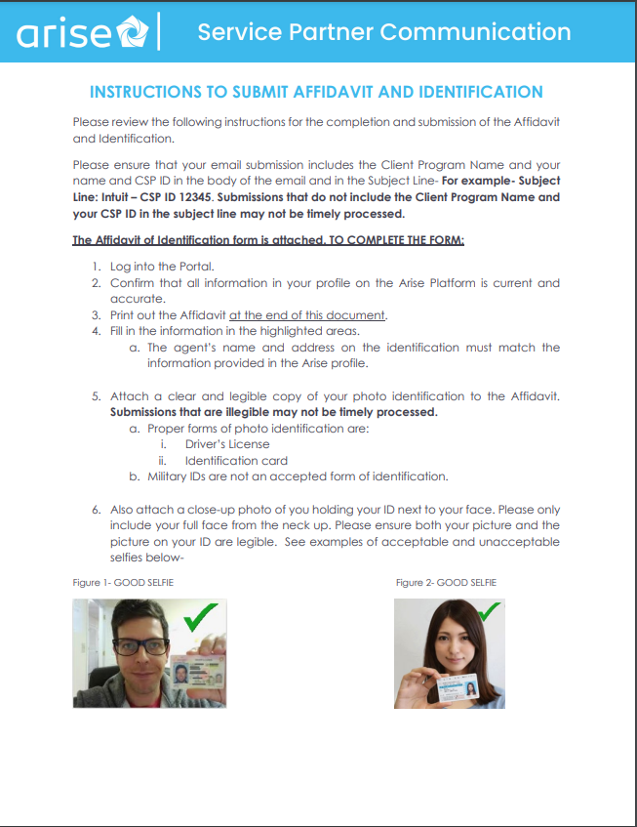
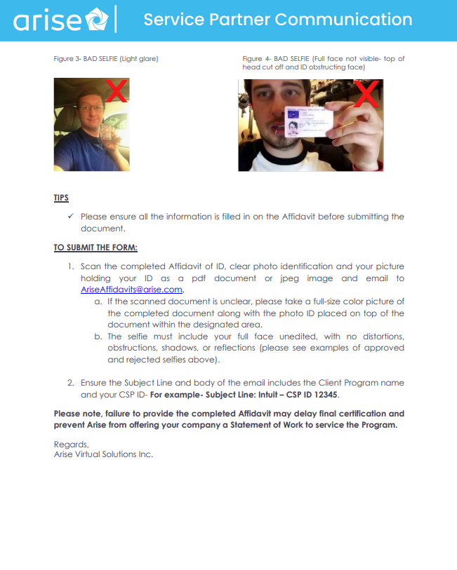

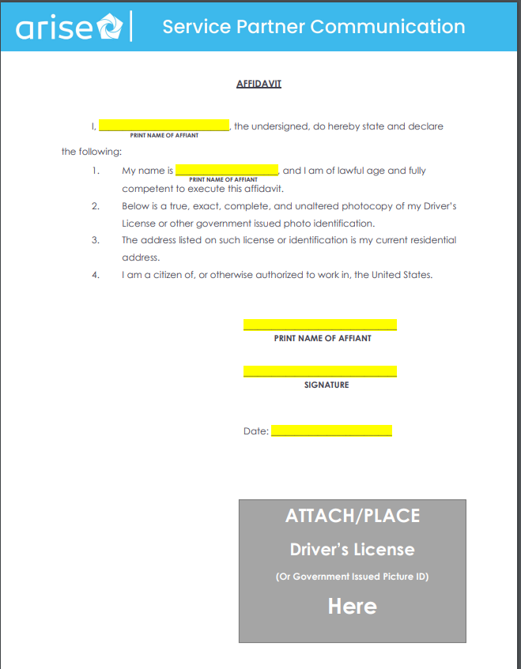

WHO TO EMAIL

It is important to make sure you are emailing the correct department for help. If you have not received a response within 72 hours, please contact Danielle Nixon by texting 561 720-9044 and she will ensure a call back from the requested department.
Texts should be in this format only
Name:
Cspid:
Email sent to which mailbox and date sent
Reason for the email

Allow us an additional 4-6 hours to have a representative reply to the sent email.

Here are all the emails addresses for both companies, the name of the Department Representative and the types of issues they all handle
Enrollment
MARY GARCIA

IMPRESSIVECOMMUNICATIONSALERTS@GMAIL.COM
ENROLLMENT@SKYMARCOMMUNICATIONS.COM
- Background check reset
- Background check status
- Affidavit status
- Course inquiries
- Course links
- When will the next course be available questions
- Fingerprints
- Course time changes
- Reset a failed step
- Interest no longer showing in the portal

Payroll
Jade G. or Alexis Collard
ImpressivePayroll@gmail.com
payroll@skymarcommunications.com
- Change of address
- Direct deposit changes
- Name changes
- Starmatic issues
- Incorrect pay
- Employee verification

General questions
Danielle Nixon, Tiffany Hill
Agentsupport@skymarcommunications.com
In the subject line please include the name of the company you are registered under
General questions that do not fit the above issues for the other email boxes
- Referrals
- Outage inquiries
- Access issues
- Portal errors

